**Standard Operating Procedure for ILSI Simulation Model: Continuous Mode**

Author: Eric (Xianbin) Cheng

# Synopsis

This is an instruction for downloading and running the ILSI simulation model (continuous mode) in R Markdown.

# Stable Versions

|  |  |  |
| --- | --- | --- |
| Version | Date | Brief Description |
| 1.0 | 2/1/2019 | * Continuous mode and discrete mode are inseparable |
| 2.0.1 | 4/25/2019 | * Continuous mode is separated from discrete mode * Decay functions include “exp”, “norm”, “unif” |
| 2.1.2 | 5/9/2019 | * Contamination types include point-source and area-based |

# Downloading

To run the simulation model, you need to download the correct version of R scripts and Markdown files. We will show the procedure of downloading model version 2.1.2 as an example.

1. Open Eric Cheng’s GitHub page
   1. <https://github.com/ericxbcheng/ILSI_remote_repo>
2. Find the code for ILSI model version 2.1.2
   1. Click the button for “commits”.

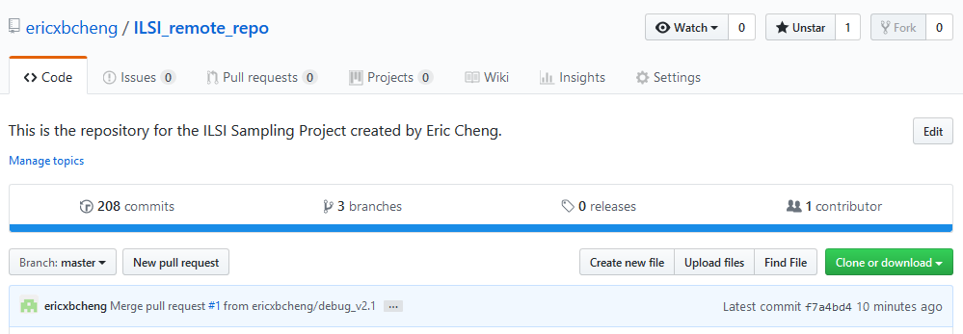

* 1. Find the commits made on May 9, 2019 from the **master** branch.

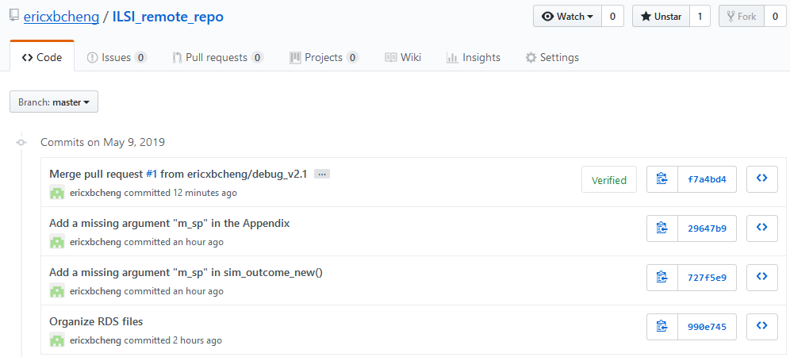

* 1. Browse the repository at this point in the history.

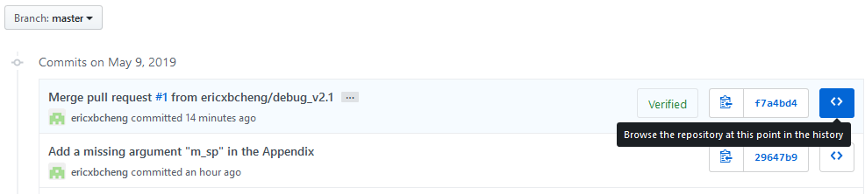

* 1. Download all the files.

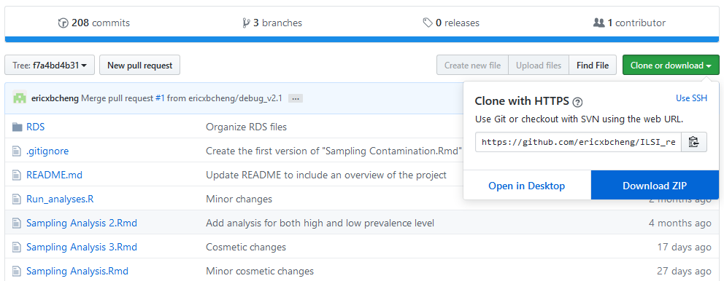

1. Extract everything from the ZIP file and put them in a new folder.

# Installation

1. Installation of R and R Studio
   1. Install R first, then R Studio
2. Installation of R packages
   1. Open the R script **Sampling_libraries.R**
   2. Install *ALL* the packages listed in this script.
      1. Option 1:
         1. Go to “Tools” 🡪 “Install Packages” 🡪 type in each package’s name
      2. Option 2:
         1. Navigate to the console.
         2. Use install.packages(…) to install the packages.
            1. For example: install.packages(“tidyverse”), …

# Model Running

1. Open the Markdown file **Sampling Continuous Mode.Rmd.**
2. Knit the Markdown file into an HTML file.
3. Open the HTML file you just knitted and read the instruction inside.
4. Adjust input parameters.

# Model Structure

For the purpose of debugging, function call graphs are presented to illustrate the structure of model version 2.1.1. Functions are denoted by rounded rectangles and IF-ELSE statements are denoted by diamonds. In terms of the function names, “cont” indicates continuous mode and “dis” indicates discrete mode. A function on the left, if ran by the user, will call functions on the right.

L01 d i 玒 2- 1 
9m i 111 
Get 11 
L01 d i 玒 2- 1 
L01 d i 玒 2- 1 

Machine generated alternative text:



# Changes History

|  |  |
| --- | --- |
| Date | Update |
| 05/06/2019 | * Created the document |
| 05/09/2019 | * Upgraded the model from v2.1.1 to v2.1.2   + Added the missing argument “m_sp” |